Time Banking In Prisons
A Fair Shares Initiative
March 2013

Contents

Introduction Page 2
Fair Shares Gloucestershire Page 2
What is Time banking? Page 2
History Page 2
Process Page 3
Partnership Working Page 3
Daily running of the project Page 4
Challenges Page 5
Challenges to aims of the project Page 5
Common Institutional barriers Page 6
Resistance to the Fair Shares Model Page 6
Successes and examples Page 8
Future Page 10
Introduction
Fair Shares Gloucestershire
Fair Shares Gloucestershire was set up in January 1998 to create the UK’s first time bank and to explore ways of using time to rebuild communities. We are a Registered Charity, number 1110418.
We now run eight time banks in Gloucestershire based in Gloucester, Newent & Forest of Dean, North Cotswolds, South Cotswolds, Stratford Upon Avon, Stroud, Cheltenham and Tewkesbury as well as a charity shop in Stonehouse, Stroud.
What is time banking?
Time banks are community based projects which meet every day needs through the exchange of time, skills and opportunities. For every hour you spend helping someone, you are entitled to an hour’s help in return. The time bank creates a mutually supportive network of neighbours helping neighbours and helps turn strangers into friends.
For every hour spent helping in the community, one time credit is earned and recorded at the time bank; similarly, when asking for help, people can spend their time credits.
The help provided is in many forms – practical tasks such as gardening, befriending, running errands, providing transport or helping someone learn a new skill.
History
Fair Shares partnership with HMP Gloucester stems from 2004-2013. The project established itself in 2004 when an existing Time Broker approached the prison and introduced the idea of bringing time banking to a new community.
The initial aims of the project encircled the notion of keeping prisoners engaged with their family in their pre-existing communities through the process of contributing to the family unit through the use of time credits even whilst serving time in Prison. Time banking had already established itself as a fantastic way to engage the local community; extending the principles to the nearby prison was the next logical step in order to develop its potential as a tool for community engagement.

Process
Partnership Working
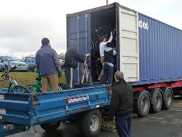
The project has been supported heavily through partnership working with the charity Jole Rider. In the early stages of the prison work, a bicycle repair shop was created within HMP Gloucester. Within the workshop, parts, paint and bike stands were financed by Fair Shares, whilst Jole Rider supplied old bikes that needed repairs. Prisoners were then able to learn new skills, through a tutor in the workshop, and work towards repairing the bikes. These bikes were then distributed in a number of ways. Firstly, Jole Rider were able to take the bikes to Gambia to help isolated villages, secondly, Fair Shares were able to donate bikes to participants in the community, (sometimes this meant giving a victim of bike theft a replacement) and thirdly Fair Shares were able to donate the bikes to other partner organisations such as women’s centres and schools to help aid others learning to ride a bike.
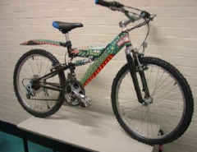
For every hour each prisoner worked within the bike shop, they were rewarded with one time credit. They could then spend this time credit by donating it to their families, allowing their families to receive an hour of help for each credit.
Not only did the workshop allow prisoners to feel they were contributing to the family unit, but it also allowed them to learn new skills and work towards a target. Fair Shares were able to provide certificates for prisoners once they had reached a certain amount of hours, and had met a set of criteria allowing them to recognise that they were developing their skill set. Feedback from the certificates was excellent, as for many, this was also the first certificate they had ever received.
Since the start of the project, the bike workshop has remained an integral part of the scheme. New partnerships have been made with organisations such as The Shannon trust and The Samaritans. Through these partnerships, Fair Shares has been able to extend the breadth of the project, allowing those prisoners who volunteer on the Listener scheme and Toe by Toe scheme to also bank their hours. To date, Fair Shares are proud to have worked across the prison in many different areas also including; diversity reps, the library service and prison visitors in partnership with the Castle Gate Visitors centre and Infobuzz.
Daily running of the project
On a daily basis, the project runs itself. Hours worked by prisoners can be logged by either a contact in the prison or a lead prisoner themselves. Within HMP Gloucester, a lead contact would fill in an hour’s sheet and email them to the appropriate time broker on a monthly basis. The time broker was then able to input the hours on to their data base and distribute them accordingly within the community.
Usually the time broker would visit the prison on average once a fortnight. During this visit, the time broker would liaise with the prisoners in a group setting to find out how they were all progressing on their projects (e.g bike workshop) and ask if there was any changes in how they would like their hours donated.
During this visit, the time broker would also sign up any new participants to the scheme. This would involve either talking to a group or one to one’s with individuals such as those joining the toe by toe scheme or the Samaritans listeners. The Time broker would explain the scheme and aid the prisoner in filling in a prison application form.
These visits also allowed a nice opportunity for the time broker to feed back about the work being done in the community due to the hours donated by the prisoners. This was found to be a great way of motivating the prisoners to continue and make them feel like the work they were doing was worthwhile.
If hours had not been emailed across to the time broker, these visits also allowed for hours to be chased and records to be kept up to date, allowing prisoners to work towards their certificates.

Challenges
Challenges to aims of the project
Once the project was operating within HMP Gloucester, it became clear that many prisoners did not wish to donate their hours to members of family for a multitude of reasons. These included; the prisoners themselves were not from Gloucester, their home town did not have a time bank, and simply, prisoners would rather donate to charity.
Whilst the scheme aimed to allow prisoners to stay connected with their family, many prisoners did not originate from the Gloucester area posing challenges to the key aim. With over 300 time banks across the country, Fair Shares were able to get in touch with time banks in the area of prisoners home towns and liaise with them to still allow the transaction of time credits to work and the families to receive help. Through this idea, Fair Shares have successfully helped families in London, Bath and Bristol whilst their spouse remains in HMP Gloucester.
In order to aid the wishes of some prisoners to donate to charity, a new initiative was set up called the ‘Good Will Pot’. The Good Will Pot allowed prisoners to donate their time credits to the pot, which was then used to distribute hours to those in need in the community who are not able to put much back in, examples of such groups include the elderly and those who have recently been injured. This was also recognised as a particularly good way of allowing prisoners to feel like they were paying back the community they perhaps offended against. Whilst it would be inappropriate for the prisoner to directly help the victim of their offence, the Good Will Pot allowed the prisoners to feel like they were actually doing something. This idea would later be advanced further and used within Restorative Justice.
The initiative was then developed even further in to a second Good Will Pot, but this time one specifically for the prison. The prison good will pot, allowed prisoners to donate their hours in to a pot which was accessible by other prisoners, who were perhaps not able to volunteer or work in prison and not able to earn their own time credits.
Thirdly, a new partnership was formed in order to help those prisoners who wished to stay in contact with their families but no local suitable time bank was around. Fair Shares contacted the charity Story Book Dad’s, who already had a successful history of allowing prisoners to record stories to send home to their families. Through partnership with this charity, Fair Shares were able to record prisoners reading bed time stories, but also provided the opportunity for prisoners to read out letters to older children or their partners.
Common Institutional barriers
As with working with any new institution, there are barriers often faced due to learning new ways of how things work. This was no exception when it came to forging a relationship with the prison service.
Firstly, access to the prison can prove difficult. Enhanced CRB checks, security training and key training where applicable will be required which can take months to be arranged. Whilst this time proves frustrating as access to the prison is limited, the time can be used wisely by continuing meetings with prison staff ensuring everything is in place and the necessary support is in place for when you can begin.
This leads to a second key issue; support from prison staff. In the instance of HMP Gloucester, finding one main contact at the prison became invaluable. Having one member of staff who would liaise with other members of prison staff and who believed in what Fair Shares as an organization had to offer, allowed communication to be easy and effective. It has been found that prison staff can be reluctant to work with Fair Shares, due to them believing it would create a heavier work load. This is simply not the case, and it relies on prison staff understanding what you have to offer to recognise this.
A third key point links to the first with the suggestion being made that strong links are made with the governor in order to help the project. Within HMP Gloucester, strong links were made and the governor was fully on-board with the project. This allowed the work Fair Shares were doing to infiltrate through the prison, and made requests for information a lot easier.
Resistance to the Fair Shares Model
The work of the project is occasionally met with some resistance, with questions often asked such as ‘why don’t you just help them (people) anyway’ ‘why do you need us to donate hours.’ The answers to these questions stem back to the ethos of Time banking, and the core principles of co-production. Co-production encompasses values such as viewing people as assets and reciprocity. Through the Fair Shares model, prisoners are empowered to believe that they too have something to contribute to society, allowing integration back in to the community to be a smoother process as prisoners feel less distanced from society due to their donated hours. Through the value of reciprocity, prisoners are also able to feel as if they have given back. Those receiving help in the community as a result of the prisoners donated hours are always grateful and many think it is an excellent way for prisoners to stay connected to their community.
If prisoners become involved with Fair Shares whilst in prison, they can also continue to participate upon release. This is an excellent way for prisoners to quickly integrate back in to their community without feeling isolated.

Successes and examples
The option for prisoners to make a video has been one of the most popular within the project, and there is often a waiting list, due to a lack of editing facilities.
Recently, Fair Shares were able to create special Christmas videos to send out to five families. Feedback from this project was incredible; here are a couple of quotes to share;
‘My daughter can now watch Daddy whenever she wants, thank you.’
‘The whole family were able to watch the film on Boxing Day, it made our Christmas.’
Through quotes like these, the community impact the project has starts to become clear. The use of the community good will pot has been phenomenal, with most prisoners choosing to donate their hours to the community. Through these donated hours, Fair Shares have been able to help a number of elderly participants. Many of these participants have been with Fair Shares for a long time but due to their age or increasing health problems they can no longer give their time as they used too. They now receive what Fair Shares refer to as a ‘pension’ from the community good will pot using the hours donated by the prisoners. Below are a few quotes showing what our participants have said about the pension scheme;
‘Without the support from the pension scheme I would be really lonely, it’s lovely to have someone visit me on a regular basis and know there is someone that can help me.’
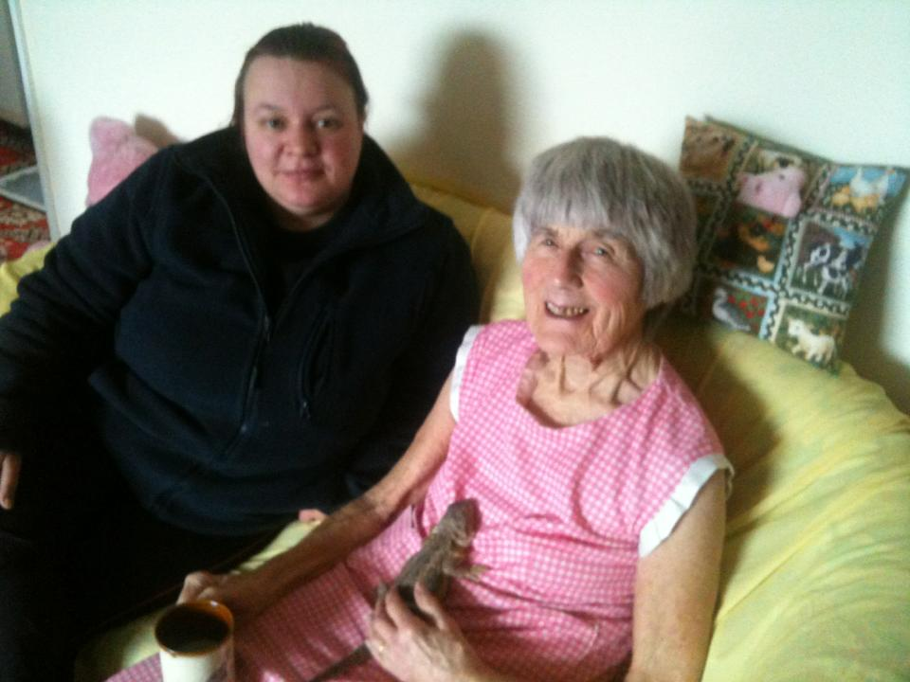
‘Without Fair Shares and the pension scheme I would be lost. Most other organisations wouldn’t help me as I’m a bit of a hoarder; but Fair Shares found a volunteer to do my shopping who doesn’t mind my mess! I am house bound too and really look forward to my regular chats with my volunteers; I feel that I’m not alone.’
‘Fair Shares has helped me enjoy life more, I love dogs but due to my age can’t have one of my own. Fair shares organised a lovely lady to visit me every week with her four dogs and it’s so nice to see them all and have a chat. I also met my first pet dragon last week! (See picture)’

The project has also recently extended its partnership working to include links with Victim Support. As previously mentioned, whilst it would be inappropriate for prisoners to directly help victims of their crimes, through time banking, prisoners are able to donate hours to the good will pot which Victim Support are able to access. This idea has also been established with restorative justice, allowing both the prisoner and the victim to feel a sense of reciprocity and has proved to be very successful.

Stonehouse Charity Shop
Fair Shares were successfully able to facilitate having a prisoner on ROTL work in the charity shop five days a week. Through close partnership with HMP Gloucester and their desire to become more of a community prison, the first category D prisoner was successfully able to work through the gate. Whilst this was only in the early stages before the closure of the prison was announced, it was deemed to have been a success with the prison able to gain confidence and other skills prior to release. Below is a quote from the Shop Manager;
‘… was a major asset to the shop, he was hard working, enthusiastic, good with customers and volunteers, he had a good concept of the benefits of the shop and it as an asset to the charity. He took instructions well. I believe he felt he benefited from the time with us, enabling him to begin to reintegrate with the outside world.’

‘

Future
With the recent closure of HMP Gloucester, Fair Shares have been looking to introduce the project in to other prisons in the surrounding area. Links with HMP Leyhill have already been established and initial meetings have taken place in order to progress further.
It has come to Fair Shares attention, that the project may need adapting to suit other prisons. Whilst HMP Gloucester, was a category B prison, Leyhill is Category D and thus the level of opportunities at each prison varied significantly. Whilst the film project was a huge success at Gloucester, it was discovered that Leyhill prisoners often had many more opportunities to see their families and perhaps a film would not be as appreciated there.
It was also discovered that a lot of activity was already happening at Leyhill, which although positively would generate a lot of time credits, on a realistic level it was noted that not all of these hours would be spent due to such a mass amount of them. Ideas have been discussed surrounding a limit on how many time credits can be earned in a week, in order to track how they are spent.
From this, the prison project is being evaluated and reviewed to see how it can best fit in to new prisons, and it has been noted that it may vary depending on where the project is taken.
Fair Shares are exceedingly proud of the prison project and are keen to work with other charities and organizations to carry on the good work. If you have any queries or questions or are interested in becoming involved, please contact us using the following contact details:
Fair Shares
City Works,
Alfred Street,
Gloucester,
Gl1 4DF
01452 415900

