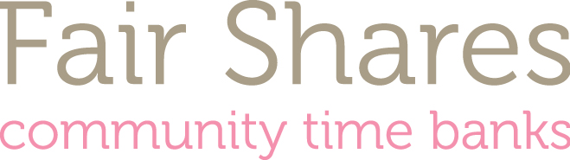

APPLICATION FOR EMPLOYMENT (part 1)

CONFIDENTIAL

For office use only
Post applied for:
Prison Project Administrator
Location:
Chequers Bridge Centre, Gloucester
Closing date: 10th February 5pm

Equal Opportunities

Fair Shares is committed to promoting equal opportunities and aims to be an inclusive organisation where everyone is treated with respect and dignity, and where there is equal opportunity for all. Fair Shares is committed to equal opportunities in employment and is committed to developing equality of opportunity in all areas of its work and structure. All job applicants and employees shall receive equal treatment regardless of age, disability, gender reassignment, marriage and civil partnership, pregnancy and maternity, race, religion or beliefs, sex and sexual orientation.
Please complete in black ink and in block capital. Please do not include a CV as shortlisting will be based on application forms and the covering letter.

How did you hear of this post? (Please state name of publication etc)

Title: Surname:

First Names:

Address: Home Tel:

Postcode: Daytime Tel:

Do you have a full driving licence?
Do you have regular use of a car or are you able to travel to other locations within Gloucestershire as required?
Have you ever been convicted of any criminal offence?
If yes, please give details on separate sheet.
Please state number of days you have been absent from work due to sickness in the past twelve months
How many periods of absence does this represent?
Please give dates on which you will NOT be available for interview, e.g. holidays | Interview date will be Tuesday 21st February 2017

If selected, when could you start?
(Please give period of notice if applicable)

Please give details of two referees below
Name  Address  Tel No  Email  Can we contact this person before prior to a job offer being made? Yes/No | Name  Address  Tel No  Email  Can we contact this person before prior to a job offer being made? Yes/No

I declare that the information provided on this form is correct and includes all relevant information which may affect my suitability for employment within the Charity and I understand that my engagement and employment are dependent upon this declaration.

In accordance with the Data Protection Act 1998 I give my consent for the information contained in this form to be processed for the purposes of my recruitment and employment with Fair Shares Gloucestershire. I understand this application form will become part of my personal file and that if I am not appointed it will be stored for six months and then destroyed.

Signature: Date:

